  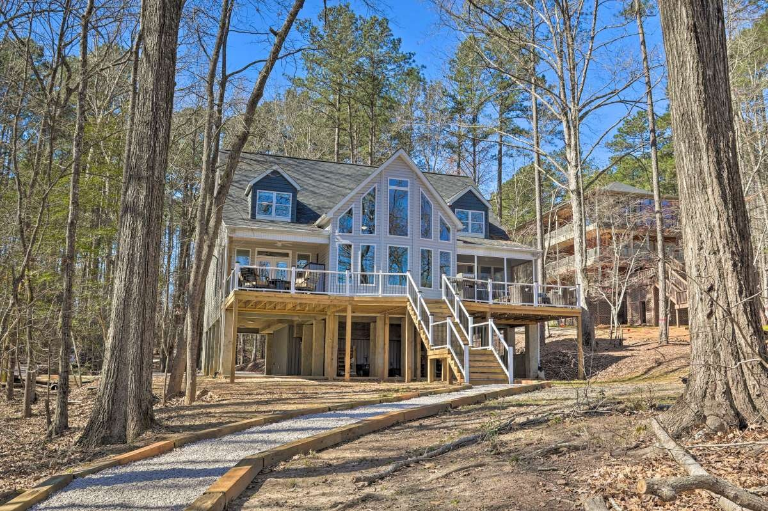
    - 863 WoodsIde drive
    - $950,000
  Beautiful Lakefront home on a 1.83-acre wooded lot with a winding gravel driveway down to the home. The home features 4 bedrooms; 3 baths; large great room with floor to ceiling windows for those great views; open kitchen with solid surface countertops and a large island; and 2nd floor Rec Room. Exterior features a full deck, 2 covered porches, one is screened. The home is elevated so there is room for 2 cars and other covered outdoor activity. A boardwalk leads out to the waterfront where there is a fixed and floating dock with Gazebo. This property is convenient to I-77, Rock Hill, and Charlotte.
  Sellinglakewateree.com
  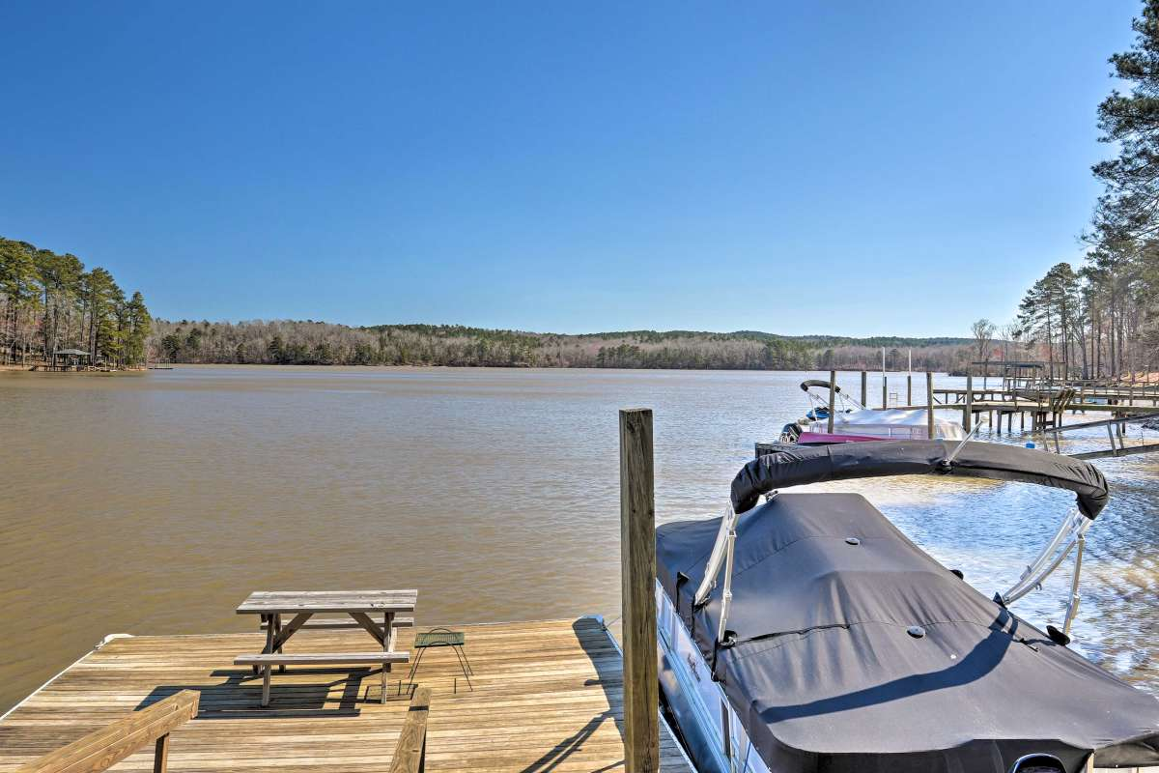
  1.83 Acres
  125 Ft of Waterfront
  
  Michael Thomas
  mikewateree01@gmail.com
  803-427-5073
  

